Online Fee Chalan Generator

## PROJECT REPORT

***Submitted by***

# Tanvi Dhimaan (19BCS3546)

# Gunit Kumar Bedi (19BCS3552)

# Yash Jain (19BCS3553)

# Shishir Verma (19BCS3560)

# Vamsi Mohan P (19BCS3583)

***in partial fulfillment for the award of the degree of***

# BACHELOR OF ENGINEERING IN

COMPUTER SCIENCE AND ENGINEERING – Information

Security (IBM)



**Chandigarh University Apex Institute of Technology**

November 2022



# Table of Content

Title Page 1

Bonafede Certificate 2

Table of Content 3

Abstract 4

List of Figures 5

Abbreviation 5

|  |  |  |
| --- | --- | --- |
| **Chapter 1.** | **Introduction** |  |
| 1.1. | Introduction | 5 |
| 1.2. | Identification of Problem | 5 |
| 1.3. | Identification of Task | 7 |
| **Chapter 2.** | **Literature Review** |  |
| 2.1. | Literature | 8 |
| 2.2. | Existing System | 10 |
| 2.3. | Proposed System | 11 |
| **Chapter 3.** | **Design Flow** |  |
| 3.1. | Data Flow chart | 12 |
| 3.2. | Role | 14 |
| 3.3. | Liberty | 14 |
| 3.4. | Design Constrains | 15 |
| 3.5. | Methodology | 15 |
| **Chapter 4.** | **Result Analysis and Validation** |  |
| 4.1. | Implementation of Solution | 19 |
| 4.2. | Problem and Solution | 23 |
| **Chapter 5.** | **Conclusion and Future Work** |  |
| 5.1. | Conclusion | 24 |
| 5.2. | Future Work | 26 |
| **References** |  | **27** |

# ABSTRACT

Chandigarh University has a large number of students who pay all the university fees through cash deposits, electronic funds transfer or bank drafts to the university’s accounts in specific bank branches. These methods of paying fees have not been efficient enough especially during periods of tests and examinations when most of the students are paying fees to meet the requirements for entering examination rooms. The process of paying fees is characterized by long queues, too much waiting by students and congestion at banks where payments are made. This has always resulted in students missing to sit for their tests and/or examinations while they are queuing to make payments. It was upon such background that the researchers embarked on the project to develop of an alternative system that enables online fees payment by students and their sponsors. With the use of questionnaires, interviews, observation and document reviews, data was collected from project stakeholders and analyzed. Data flow diagrams and Entity relationship diagrams were used to accomplish system analysis and design. The system was implemented using Apache web server, MySQL database server, Hypertext Preprocessor, Hypertext markup language, Cascading style sheets and JavaScript. System testing and validation was also done by allowing users of the system interact with it using test data.

Findings showed that most of the students were unsatisfied with the current modes of paying fees to the university and agree that an online fees payment system can improve the process of fees payment. The result of the project was an online fees payment system for Chandigarh University (CU) and researchers recommend the university to implement the system that provides relief of the long-endured problems of the current modes of payment at the university.

# List of Figures

Fig 3.1.1: Architectural design 12

Fig 3.1.2 Context Dig of CU-OFPS 13

Fig 3.1.3:Data flow chart of CU-OFPS 13

Fig 4.1.1: source code Fig 4.1.2: source code

Fig 4.1.3: source code Fig 4.1.4: Source code

Fig 4.1.5: source code

Fig 4.1.6: - Fig 4.1.15 Interface

Fig 4.1.16: Database

# List of Abbreviation

* ARIS Academic Records Information System
* ATM Automatic Teller Machine
* CSS Cascading Style Sheets
* DFD Data Flow Diagram
* ECS Electronic Clearing System
* EFT Electronic Funds Transfer
* ERD Entity Relationship Diagram
* FINIS Financial Information System
* FK Foreign Key
* HTML Hypertext Markup Language
* ID Identifier
* IS Information Systems
* CU-OFPS Online Fees Payment System for Chandigarh University
* PHP Hypertext Pre-processor
* PK Primary Key
* SQL Structured Query Language

**CHAPTER 1.**

# INTRODUCTION

## Introduction

Fees payments by students in Chandigarh University are made through cash deposits, Electronic Funds Transfer (EFT) and Bank drafts to the university’s accounts in specific bank branches. Plymouth and Martin stress that, “For nearly every business, the simple act of collecting payments from consumers is actually quite complex. Organizations want to make it easy and convenient for customers to pay, so they offer multiple choices of payment types and channels”. Therefore, the project provides an alternative method that enables secure online fees payment by students and their sponsors. In this project we are proposing a system that will have a user login and an Admin login with their own features and responsibilities.

Chandigarh University has a large number of students who are supposed to pay all the university fees through cash deposits or bank drafts to the university’s accounts in specific bank branches. This method of paying fees has not been efficient enough especially during periods of tests and examinations when most of the students are paying fees to meet the requirements for entering examination rooms. The process of fees payment in such periods is characterized by long queues, too much waiting by students and congestion at banks where payments are made. Students queue to pay fees and those who do not reach counters within the bank working hours are advised to return the next day.

This process has always resulted in students missing to sit for their tests and/or examinations while they are queuing to make payments. It has also resulted to too much costs and a lot of time used in transferring and withdrawing money whenever sponsors of students make money transfers to students who can pay university fees at specific bank branches. The process requires sponsors of students from wherever they are to send money to students through either bank, mobile money or any other possible way(s) so that students pay university fees or use EFT that require swift codes to pay fees to the university. This consumes time and sponsors incur extra costs in this process of sending money to students.

So in the proposed system will have Admin and User where admin will have to generate the fee challan and the user have to pay the generated challan or the fee the user will register in the web using his/her UIDs and they can set a preferable password for their account and they can see the due fees, fees that have been paid by the user and also if they have to pay any fine due to misbehavior or misconduct in the premises.

## Identification of Problem

The available modes of fees payment to Chandigarh University through cash deposits, Electronic Funds Transfer (EFT) and bank drafts have caused long queues, students missing to sit for their tests and examinations, and loss of money intended for fees while waiting to reach bank counters to make payments among others.

The problem is addressed by developing a system that enables students and their sponsors to securely pay university fees online from wherever they are using credit and debit cards, UPI or any online method.

## Identification of Tasks

### To review the existing system used in paying university’s fees so that its strength and weaknesses are identified.

### To design a new system that enables students and their sponsors to pay university fees online from wherever they are using credit and debit cards.

### To implement the prototype of the designed system.

### To test and validate the system prototype.

# CHAPTER 2.

**LITERATURE REVIEW**

## Literature

Chandigarh University has a large number of students who are supposed to pay all the university fees through cash deposits or bank drafts to the university’s accounts in specific bank branches. This method of paying fees has not been efficient enough especially during periods of tests and examinations when most of the students are paying fees to meet the requirements for entering examination rooms. The process of fees payment in such periods is characterized by long queues, too much waiting by students and congestion at banks where payments are made. Students queue to pay fees and those who do not reach counters within the bank working hours are advised to return the next day.

This process has always resulted in students missing to sit for their tests and/or examinations while they are queuing to make payments. It has also resulted to too much costs and a lot of time used in transferring and withdrawing money whenever sponsors of students make money transfers to students who can pay university fees at specific bank branches. The process requires sponsors of students from wherever they are to send money to students through either bank, mobile money or any other possible way(s) so that students pay university fees or use EFT that require swift codes to pay fees to the university. This consumes time and sponsors incur extra costs in this process of sending money to students.

Fees payments by students in Chandigarh University are made through cash deposits, Electronic Funds Transfer (EFT) and Bank drafts to the university’s accounts in specific bank branches. Plymouth and Martin stress that, “For nearly every business, the simple act of collecting payments from consumers is actually quite complex. Organizations want to make it easy and convenient for customers to pay, so they offer multiple choices of payment types and channels”. Therefore, the project provides an alternative method that enables secure online fees payment by students and their sponsors. In this project we are proposing a system that will have a user login and an Admin login with their own features and responsibilities.

### Dr. Sudha L K, Yuktha Raju, Vidya G, Puneeth N, Yashaswini:

The complexities in fare collection have been eliminated and the project is completed successfully using smart card. This project is made with pre-planning, that it provides flexibility in operation. This innovation has made more desirable and economical. The COLLEGE FEE PAYMENT SYSTEM is designed with the hope that it is very much economical and helpful for teachers, parents and students during journey.

### Lwanga Newton and Justus Ashaba:

### The project sought to develop an online fees payment system that provides relief of the long endured problems of the current modes of paying fees in Makerere University. Problems that students and their sponsors faced regarding paying fees to the university were identified and a solution was designed. Researchers developed a web-based system that enables students and their sponsors to pay university fees from wherever they are using credit and debit cards. This system was welcomed by all its users who believed it would solve most of the problems and improve conditions regarding paying fees in Makerere University.

The project achieved all its objectives and as a result, MUK-OFPS was designed, developed, tested and validated with real users. Hence, it was proved that this online system was fit to be implemented

## Existing System:

Chandīgarh University has an efficient and effective Financial Information System that records, monitors, and reports about student fees payment transactions and other finances in the university. Fees payments by students are made through cash deposits, electronic funds transfer and bank drafts to the university's accounts in specific bank branches and later reflected in Financial Information system which integrates with the Academic Records Information System (ARIS) that provides information on students. These methods of paying fees have not been efficient enough especially during periods of tests and examinations when most of the students are paying fees to meet the requirements for entering examination rooms. The process of fees payment in such periods is characterized by long queues, too much waiting by students and congestion at banks where payments are made. This process has always resulted in students missing to sit for their tests and/or examinations while they are queuing to make payments. It has also resulted to too much costs and a lot of time used in transferring and withdrawing money whenever sponsors of students make money transfers to students to enable pay university fees at specific bank branches.

### Drawbacks with the Existing System:

* + - Queues still exist.
    - Create a lot of hassle and inconvenience.
    - Students miss their academic examinations because of their late fee submissions.
    - Students can now keep track of their payments.
    - Students or their sponsors now can easily pay for their semester fees

## Proposed System:

The proposed system will have Admin and User where admin will have to generate the fee challan and the user have to pay the generated challan or the fee the user will register in the web using his/her UIDs and they can set a preferable password for their account and they can see the due fees, fees that have been paid by the user and also if they have to pay any fine due to misbehavior or misconduct in the premises. Admin can manage the generation of challan and the alert the message to the students/users for the payment and will have control over database and they can update the active current/Active users and will store data of passed out students in passed/In-Active students.

Students will have an interface where they will see their due fees and the fee they paid and can also keep a track on how much fee have been paid and how much is left they will be acle to manage their expenses

### Advantages with the proposed system:

* + - Allow students to make secure payments.
    - Reduce the hassle and inconvenience of paying fees.
    - Easy to use interface and great manageability.
    - Saves time on payments and keep track of every payment.

CHAPTER 3

# DESIGN FLOW

## Data Flow Chart:

### Architectural Design:

CU-OFPS is a web-based application to be hosted on a web server that communicates to a database server. The user on a web interface makes a web request which is received by the web server. The web server processes the request and interacts with the database server using SQL embedded in PHP scripts. The response is a web page data sent on the web interface for the user.

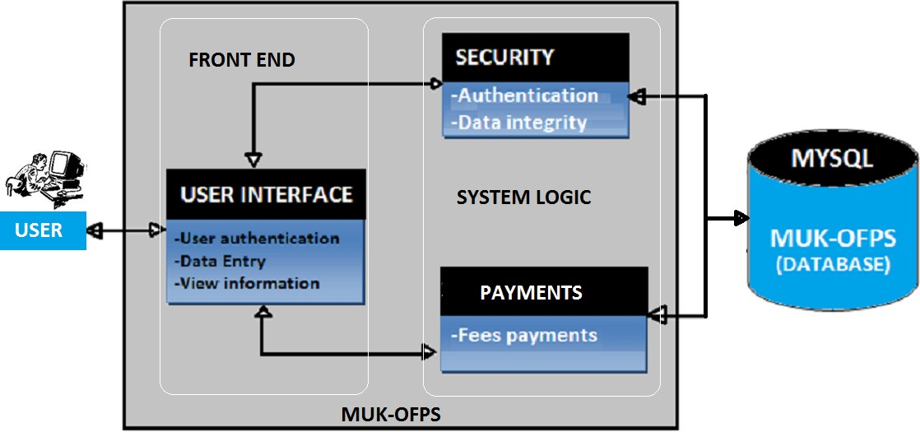

**CU-OFPS**

**Fig. 3.1.1**

**Architectural Design**

### Context Diagram for CU-OFPS

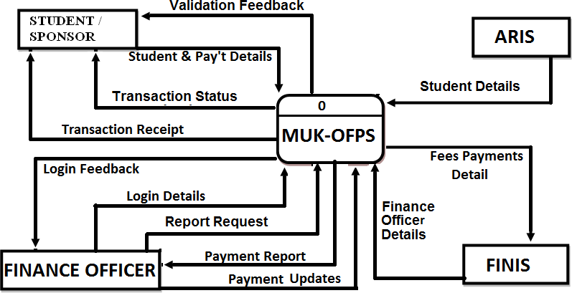

### CU-OFPS

**Fig. 3. 1.2**

.

### Data Flow Chart for CU-OFPS:

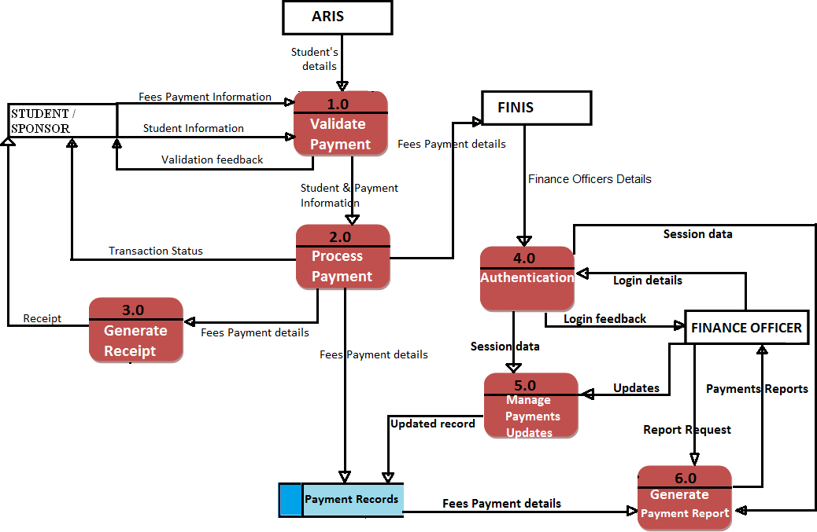

**Fig. 3.1.3**

## Roles:

There are roles like the Admin, User. Admin, the name itself defines what it is capable of. The user is the lowest in the role chain and has the least privilege. And the Admin have the most privileges

### Admin:

### The role of admin is to generate the fee challan and do generate the fee payment alert and also to manage active and in-active student’s database

### User/student:

The role of student/User is to pay their fee challans and also they can keep track of their payments.

## Liberty:

The different roles have their different rights and liberties as they need different privilege.

**Admin:**

Admin has the liberty to generate college fee and other expenses, and also to keep track of registered members.

### User/Student:

Student have liberty to pay the fee challan generated.

### Hardware Requirements:

* + - * CPU: Intel® Core™ i7-480HQ CPU @ 2.5 GHz
      * RAM: 8GB 1600MHz DDR3
      * GPU: NVIDIA GeForce GT 750M 2 GB Intel Iris Pro 1536 MB

### Software Requirements:

* + - * Operating System: Windows 10/11
      * IDE: VS Code
      * Xampp
      * Database

## Methodology:

The Methodology behind the project is to make a robust system that will ease the way of paying all the college expenses and will create a hassle-free way of keeping the records of payments before this proposed idea students used to pay by check deposit or cash deposit because of hat students have to be in long queues and some time even they get to pay late due to this and also they miss their examinations because of the delay. So, the following steps for this will be Registering in the application, generation of fee challan, payment of the fee challan, uploading the data.

### Registering on CU-OFPS:

The student will have to use CUIMS ID and Password to register on CU-OFPS and then they can access the web app and see their dues or any fee challan generated.

### Generation of Fee challan:

So, here is the role of the admin. The admin has the privilege to generate the amount of fee and it will be according to the department, every department will have their admin and all the admins have their unique login credentials and they will be in charge to generate the fee challan of the students in their department.

### Payment of Fee challan:

Once the challan have been generated you will get the alert on your user interface from their you can pay your fee challan using UPI, credit card or debit card. It will fasten the process of transaction and you can keep the transition’s evidence also this is a secure method of payment.

### Uploading the data:

After the payment the data and the transaction evidence will be uploaded in the database and hence it will show the user the fee challan have been paid and will show 0 dues .

# Chapter 4

**RESULTS ANALYSIS AND VALIDATION**

## Implementation of solution

The implementation of the solution is not much difficult as most of the hardware requirements are already satisfied and the software requirement for admin will be the server rooms so as to take load of traffic and no inconvenience will paying online and a system with intel i5 processor with 8 GB ram min to run the admin interface

### Working Implementation:

* + - * **Source Code:**

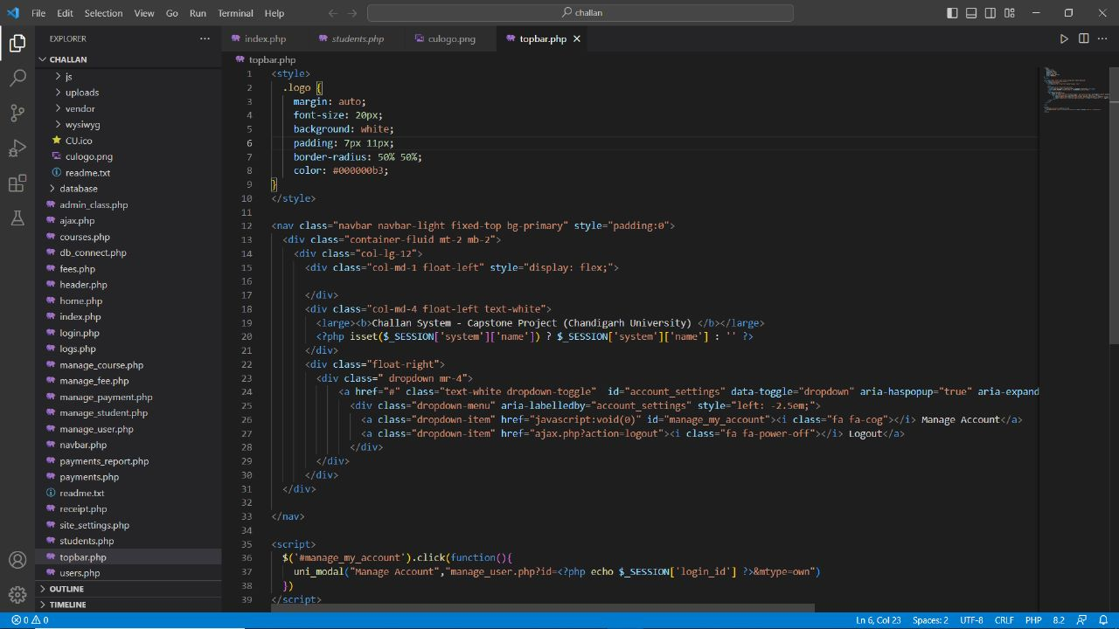

**Fig. 4.1.1 1**

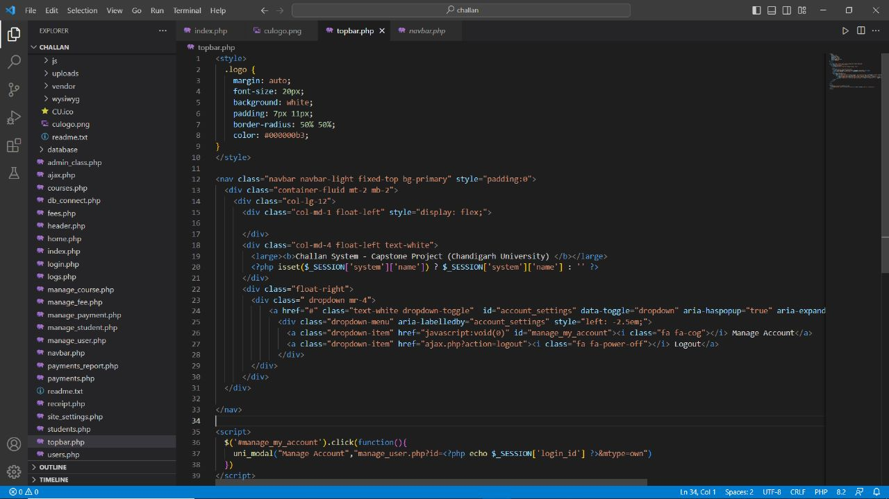

**Fig. 4.1.1 2**



**Fig. 4.1.1 3**

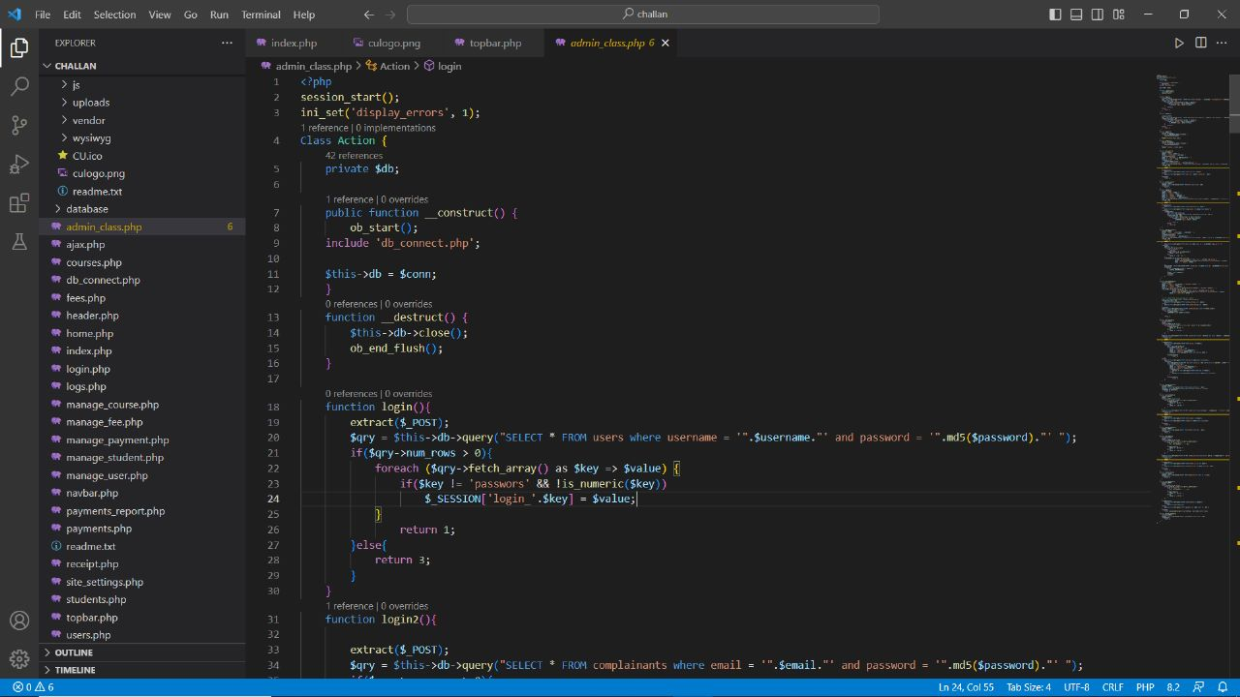

**Fig. 4.1.1 4**

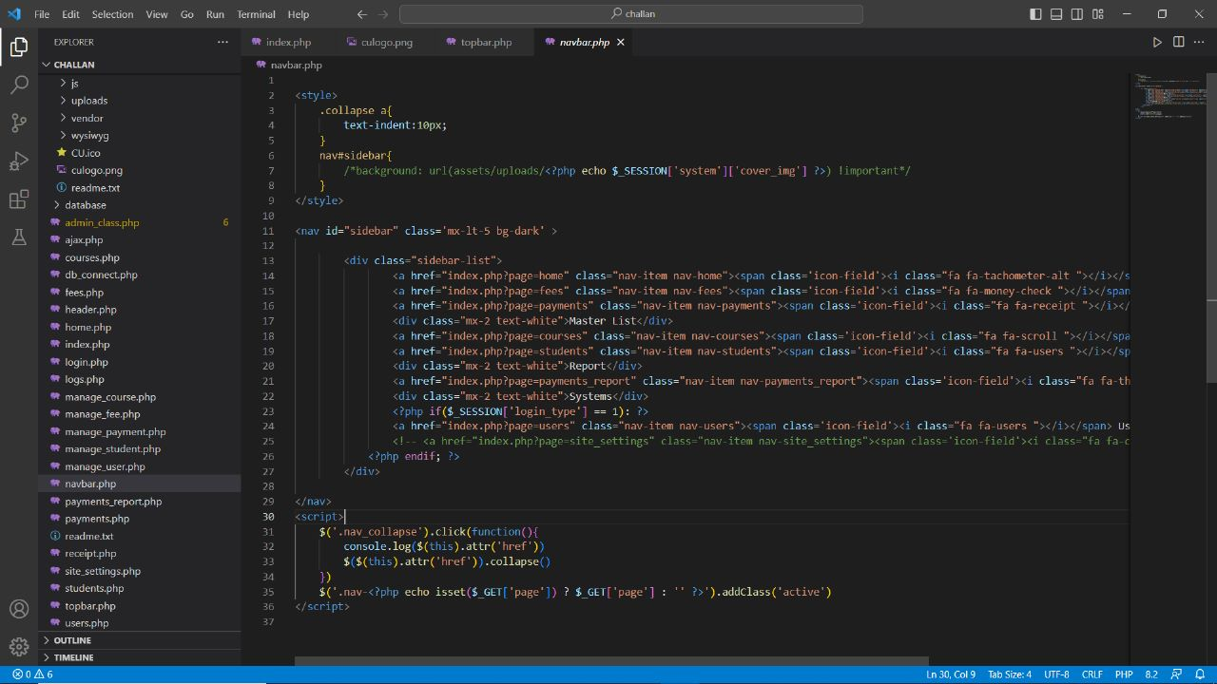

**Fig. 4.1.1 5**

.

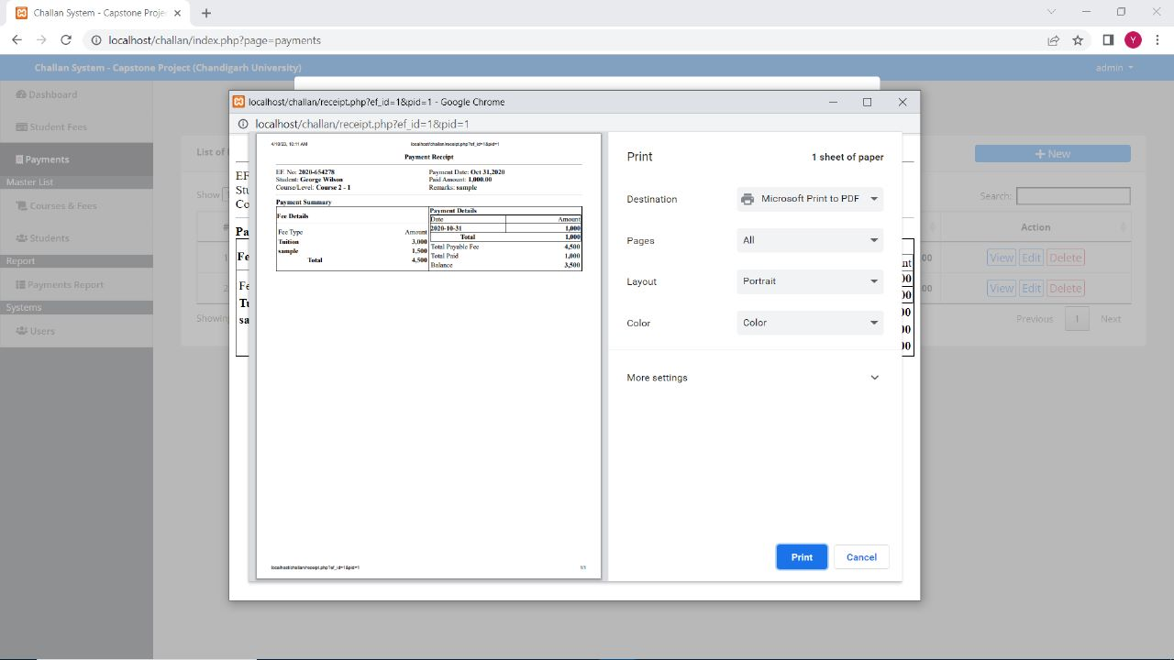

**Fig. 4.1.1 6**

### 

**Fig. 4.1.1 7**

### 

**Fig. 4.1.1 8**

### 

**Fig. 4.1.1 9**

### 

**Fig. 4.1.1 10**

### 

**Fig. 4.1.1 11**

### 

**Fig. 4.1.1 12**

### 

**Fig. 4.1.1 13**

### 

**Fig. 4.1.1 14**

### 

**Fig. 4.1.1 15**

### Database:

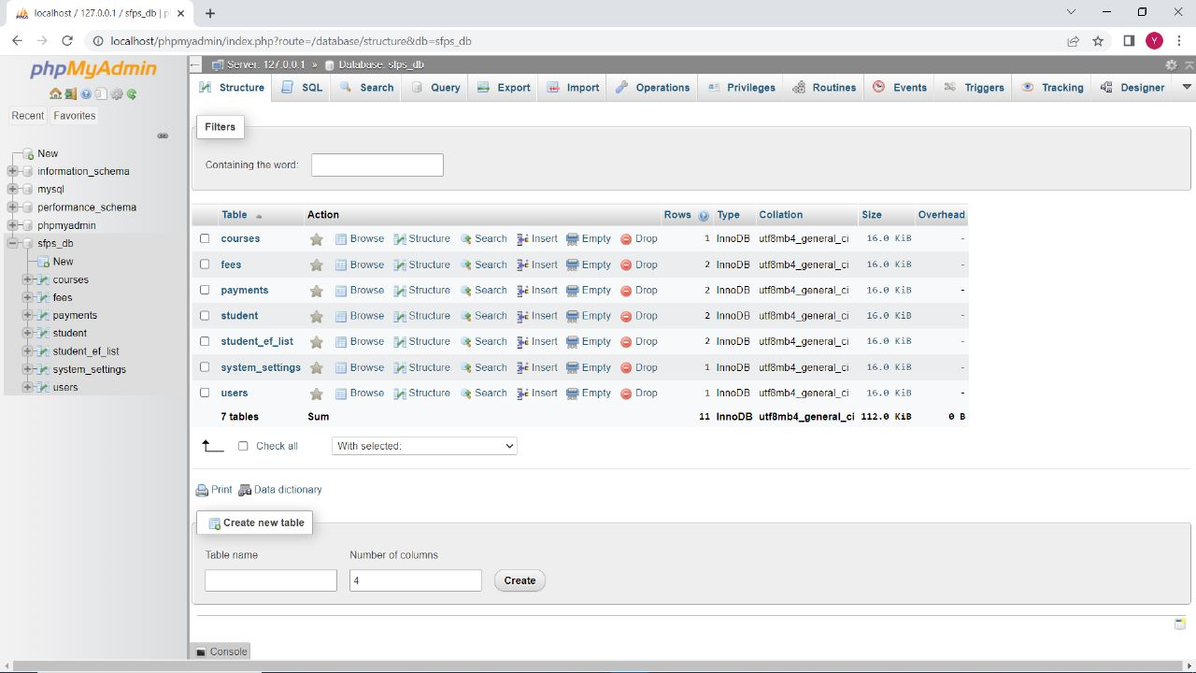

**Fig. 4.1.1 16**

### Problem and Solution:

Fees payments by students in Chandigarh University are made through cash deposits, Electronic Funds Transfer (EFT) and Bank drafts to the university’s accounts in specific bank branches. Plymouth and Martin stress that, “For nearly every business, the simple act of collecting payments from consumers is actually quite complex. Organizations want to make it easy and convenient for customers to pay, so they offer multiple choices of payment types and channels”. Therefore, the project provides an alternative method that enables secure online fees payment by students and their sponsors. In this project we are proposing a system that will have a user login and an Admin login with their own features and responsibilities.

Chandigarh University has a large number of students who are supposed to pay all the university fees through cash deposits or bank drafts to the university’s accounts in specific bank branches. This method of paying fees has not been efficient enough especially during periods of tests and examinations when most of the students are paying fees to meet the requirements for entering examination rooms. The process of fees payment in such periods is characterized by long queues, too much waiting by students and congestion at banks where payments are made. Students queue to pay fees and those who do not reach counters within the bank working hours are advised to return the next day.

The solution is the proposed system will have Admin and User where admin will have to generate the fee challan and the user have to pay the generated challan or the fee the user will register in the web using his/her UIDs and they can set a preferable password for their account and they can see the due fees, fees that have been paid by the user and also if they have to pay any fine due to misbehavior or misconduct in the premises. Admin can manage the generation of challan and the alert the message to the students/users for the payment and will have control over database and they can update the active current/Active users and will store data of passed out students in passed/In-Active students.

Students will have an interface where they will see their due fees and the fee they paid and can also keep a track on how much fee have been paid and how much is left they will be acle to manage their expenses

# CONCLUSION AND FUTURE WORK

## Conclusion

One of the main benefits of online fee challan generators is that they provide a convenient and user-friendly way for users to make payments. Users can generate their fee challans online and pay through various payment methods such as credit/debit cards, net banking, and mobile wallets. This eliminates the need for users to physically visit the institution or organization to make their payments, saving them time and effort.

Another benefit of online fee challan generators is that they can be customized to suit the needs of different institutions and organizations. They can be designed to include various fields and sections, such as student details, fee structure, due dates, and payment modes. This allows institutions and organizations to streamline their fee collection process and avoid errors or delays in payment processing.

Drawbacks of Online Fee Challan Generators

Despite their benefits, online fee challan generators also have some drawbacks. One of the main concerns is that they can be vulnerable to cyber-attacks, which can compromise the security of user data and financial transactions. Institutions and organizations must ensure that their online fee challan generators are equipped with adequate security measures, such as encryption and firewalls, to protect user data and prevent fraud.

Another potential drawback of online fee challan generators is that they may not be accessible to all users. Some users may not have access to the internet or may not be comfortable using online payment methods. Institutions and organizations must ensure that they provide alternative payment methods, such as cash or check, to accommodate such users.

User Satisfaction with Online Fee Challan Generators

Several studies have examined user satisfaction with online fee challan generators. Overall, users have reported high levels of satisfaction with these tools, citing their convenience, ease of use, and time-saving benefits. However, some users have reported issues with payment processing, such as delays or errors in payment confirmation.

Security Concerns with Online Fee Challan Generators

Several studies have also highlighted security concerns with online fee challan generators. Cyber-attacks, such as phishing and identity theft, can compromise user data and financial transactions. Institutions and organizations must ensure that their online fee challan generators are equipped with robust security measures, such as multi-factor authentication and real-time fraud detection, to protect user data and prevent fraud.

Conclusion

Overall, online fee challan generators have become a popular tool for institutions and organizations to collect fees and payments from their clients. While they offer many benefits, such as convenience and customization, they also have some drawbacks and security concerns. Institutions and organizations must ensure that their online fee challan generators are equipped with robust security measures and provide alternative payment methods to accommodate all users.

## Future work

## The future scope of this project is to make mobile app from where any student or their guardians or the sponsors can pay online and from anywhere anytime using the mobile app and pay via net banking, debit or credit card or UPI. The flexibility of paying fee will lead to on time payments and their will be no hassle while payments and the students can easily track their fee payments and in future we can give the partial payment method in which the user/student have to pay at least amount that would be 20% of the total amount. The university will have to make a separate department for this and will also have to hire software engineers to maintain and upgrade the proposed system time to time and also have to assing a security team so as to update the system with latest security systems and cyber-security systems so as to keep this system safe of the latest cyber-security threats on the web

# REFERENCES

* + 1. Agarwal, R., & Goyal, M. (2017). Online Fee Collection System: A Case Study. International Journal of Innovative Research in Science, Engineering and Technology, 6(1), 1-7.
    2. Bhatia, A., & Vashist, R. (2018). Automated Fee Collection System in Educational Institutions using PHP and MySQL. International Journal of Computer Sciences and Engineering, 6(6), 66-72.
    3. Gupta, S., Kumar, S., & Singh, M. (2016). An Efficient Online Fee Collection System. International Journal of Innovative Research in Computer and Communication Engineering, 4(5), 422-426.
    4. Kaushik, S., & Suman, A. (2018). Design and Implementation of an Online Fee Collection System for Educational Institutions. International Journal of Computer Science and Mobile Computing, 7(5), 57-61.
    5. Patil, S., & Patil, A. (2019). Online Fee Payment and Management System for Educational Institutions. International Journal of Emerging Trends in Engineering Research, 7(3), 66-70